Thermocouple Lab Report

Thermocouple Lab

by

Andrew Struthers

This lab was to demonstrate the proper use of an NI Data Acquisition Device (DAQ) and simple voltage conversion to find the Fahrenheit and Celsius temperature from a Type K Thermocouple.

Introduction

The main point of this experiment is to gather temperature data from a Type-K Thermocouple using an NI Data Acquisition Device (DAQ). The lab involves using a NI-9211 module for the DAQ, a Type-K Thermocouple with a Cold Junction Compensation (CJC) offset. The software used is NI software version 18.0 for the coding and other software. This experiment involves measuring temperature using a thermocouple. The process will include acquiring voltage readings from the thermocouple, using the datasheet to do the conversion to temperature, then displaying to a graph. The theory is that, by using a CJC offset specified using the software, a Type-K thermocouple can accurately display the temperature of the room.

Software

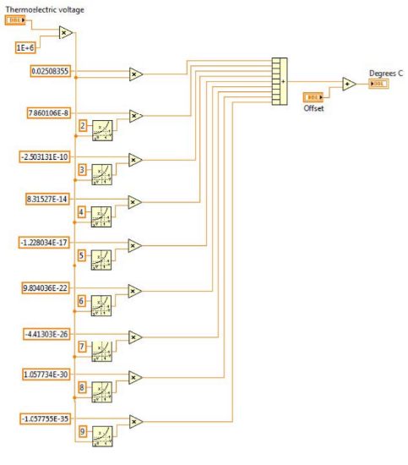To start this lab, two different VI’s needed to be created. A SubVI to convert from voltage to Celsius. This SubVI will be used in the VI, but to keep everything simple and easy to read, the converter will be embedded into the first VI. The code for the converter is displayed in Figure 1. This code accepts a voltage input and a CJC input and, using the spec sheet for the thermocouple and the CJC value, returns the degrees Celsius for the given voltage. As seen in Figure 1, the voltage comes in at the top and goes through a series of different arithmetic expressions specified in the datasheet, before being summed then added to the offset, before returning an actual voltage.

The second step of this lab was to build the front end of the VI that uses the DAQ to gather data, and charts to graph the data. The DAQ provides a voltage from the NI-9211 and the Type-K Thermocouple. The front end VI needs to have two waveform charts, a manual input for the CJC offset, and probably two displays for the current Fahrenheit and Celsius temperatures. Figure 2 is a screenshot of what the front end VI looks like after being set up correctly. There are two different charts and two different double outputs, one set for Celsius and one set for Fahrenheit. There is also an integer selector for the CJC offset so that the thermocouple output can be adjusted for accuracy. There is also a Boolean stop button that will end the program on a button click.

Figure - NI Code for Converter VI

A screenshot of a cell phone

Description generated with very high confidenceIn addition to the front panel, demonstrated in Figure 2, the display VI code is displayed in Figure 3. The DAQ assistant VI is responsible for gathering the data from the actual NI-9211 module. The stop button and the end condition of the while loop are both wired to the DAQ assistant so that the user can control when the DAQ assistant and the rest of the code are running. The SubVI is shown in the center of the screenshot, surrounded by a green box. The SubVI takes the output from the DAQ assistant and a CJC offset from the front end of the VI, and outputs the degrees Celsius. This output is directly wired to the Celsius waveform chart and double display. There is also a branch that runs through a Celsius to Fahrenheit conversion equation, and the result gets wired to the Fahrenheit waveform chart and double display.

Figure - Screenshot of the Front-End Display VI

Hardware

With these two pieces of code complete, the software side of the lab is done, and the hardware section can be finished. The only hardware involved in this lab is the Type-K Thermocouple wired to the NI-9211 module and the DAQ device. This was simple, and after it was completed, data could start to be gathered.

Figure 3 – NI Code for the Display VI

A screenshot of a computer

Description generated with very high confidenceResults

The results of this lab were as expected. The module started collecting data from the thermocouple, and the resulting converted temperatures were displayed on the graphs and the numeric displays. The offset adjustment took a little bit to figure out and set to the correct value to provide the correct temperature reading. The results were exactly as expected and measured against the thermostat in the room. The room is roughly 74 degrees during the day.

References

The references were as follows:

* Thermocouple Lab Description - <https://canvas.cwu.edu/courses/56610/files/5540182/download?wrap=1>
* Thermocouple and RTD Datasheet - <https://canvas.cwu.edu/courses/56610/files/5540181/download?wrap=1>